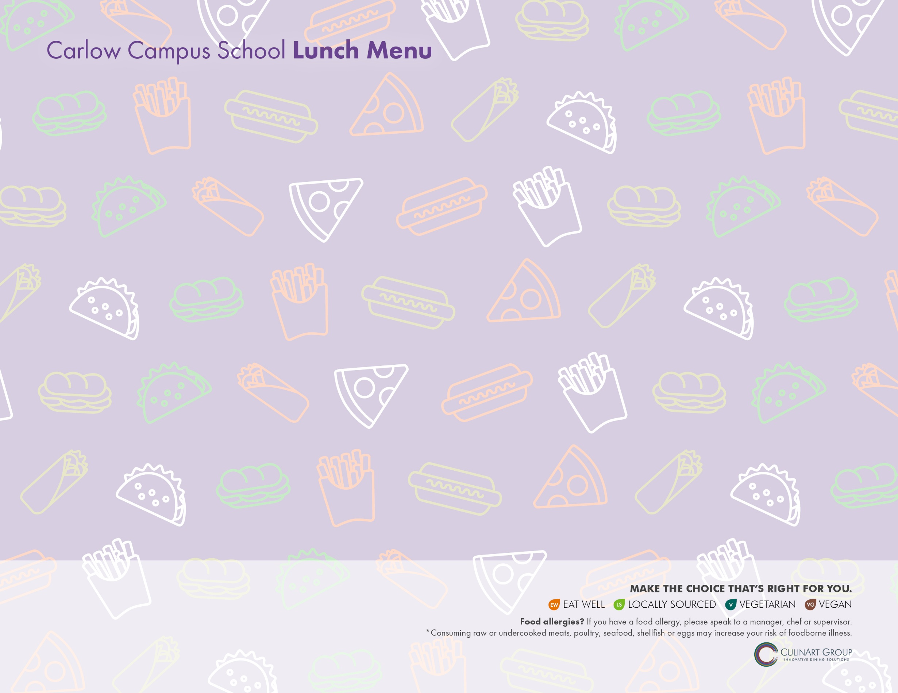**June 2021**

|  |  |  |  |  |
| --- | --- | --- | --- | --- |
| **MONDAY** | **TUESDAY** | **WEDNESDAY** | **THURSDAY** | **FRIDAY** |
|  | **1 TACO TUESDAY**  Turkey, Avocado & Cheese Quesadilla  Fiesta Power Pack – Corn Chips, Pepper Jack Cheese Cubes, Guacamole, Salsa  *Rotating Side: Fresh Mixed Fruit/ Jell-O/ Pudding* | **2** Italian Combo Wrap with Ham, Roast Beef & Salami  Celery & Carrots with Cucumber & Yogurt Dip  *Rotating Side: Fresh Mixed Fruit/ Jell-O/ Pudding* | **3** Chicken Tenders & French Fries  **OR**  Peanut butter, Apple & Honey on Whole Wheat  Veggie Sticks & Roasted Garlic Hummus  *Rotating Side: Fresh Mixed Fruit/ Jell-O/ Pudding* | **4 PIZZERIA DAY**  Cheese Pizza Bagel  Pepperoni Pizza Bagel  Garden Side Salad  *Rotating Side: Fresh Mixed Fruit/ Jell-O/ Pudding* |
| **7** Balsamic Glazed Veggie &  Hummus Wheat Wrap  **OR**  Chicken Tenders & French Fries  Carrots, Celery, Tomatoes with Ranch  *Rotating Side: Fresh Mixed Fruit/ Jell-O/ Pudding* | **18 TACO TUESDAY**  Tex Mex Taco Pocket  Fiesta Power Pack – Corn Chips, Pepper Jack Cheese Cubes, Guacamole, Salsa  *Rotating Side: Fresh Mixed Fruit/ Jell-O/ Pudding* |  |  |  |
|  |  |  |  |  |
|  |  |  |  |  |
|  |  |  |  |  |

**ALTERNATE MEAL OPTION** Buttered Pasta

**CHOICE OF MILK** 2% White, 1% Chocolate, Strawberry, Skim or Lactaid

**CHOICE OF JUICE** Apple, Cranberry or Orange